**针对他人烦恼提建议**

**【写作任务】 (Section B 3c)**

英语课上，老师让同桌之间讨论各自的烦恼，并就对方的烦恼提出建议。假如你的同桌Sam有两个烦恼：一是因为写作业睡得晚，导致他每天都觉得很累；二是马上要考试了，他感到很紧张。请你根据Sam的烦恼写一篇短文，给出解决办法，在下节口语课上展示。

**【审清题目】**

**内容**：针对他人的烦恼提出建议。

**文体**：说明文

**时态**：以一般现在时为主

**人称**：以第三人称为主

**【头脑风暴】**

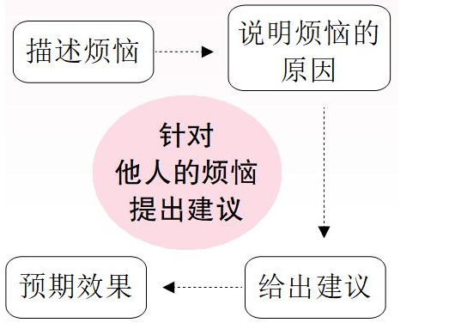

**【提供素材】**

|  |  |  |  |
| --- | --- | --- | --- |
| **Problems** | **Reasons** | **Advice** | **Consequences** |
| Feel tired | Be lack of (缺乏)  sleep | Do homework as soon as he / she gets home;  Don’t spend too much time playing and (1)______________(不要熬夜). | He / She will get enough sleep. |
| Feel nervous (焦虑的)  before exams | Be worried about his / her exam results | Exercise or listen to music;  Prepare himself / herself well for the exams. | He / She will feel relaxed and confident (自信的) when taking exams. |
| Feel stressed (有压力的) | Have no / little time for hobbies | (2)______________(为学习和爱好制定一个计划). | He / She will have time to enjoy his / her hobbies. |
| Get short-sighted (近视的) | Read books in the sun or in bed | (3)______________(以正确的方式阅读);  Wear the right glasses. | His / Her eyesight (视力) will not get worse. |
| Get heavy | Eat too much junk food and hardly exercise | Don’t use pocket money (零花钱) to buy snacks (零食) but to buy something useful;  (4)______________(每天做运动). | He / She will get healthy. |

**Key:**

1. don’t stay up late

2. Make a plan for studies and hobbies

3. Read in a right way

4. Do / Take exercise / Do / Play sports every day

**【谋篇布局】**

将括号内的汉语翻译成英语，补全短文。

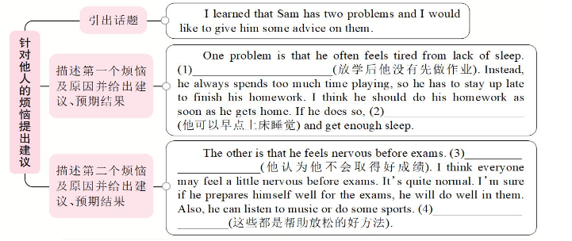

**Key:**

1. He doesn’t do his homework first after school

2. he will be able to go to bed early / he can go to bed early

3. He doesn’t think he will get good grades

4. These are all good ways to help relax

**◆句型**

• I’d like to give ... some advice.

• I think he / she should ...

• If he / she ..., he / she will ...

• If he / she takes / follows my advice, he / she will ...

• Why not ...?

• He / She’d better ...

• It’s better for him / her to ...

**Key:**

1. don’t stay up late

2. Make a plan for studies and hobbies

3. Read in a right way

4. Do / Take exercise / Do / Play sports every day